Chapter 9, Problem 32.

Using Fig. 9.40, design a problem to help other students better understand phasor relationships for circuit elements.
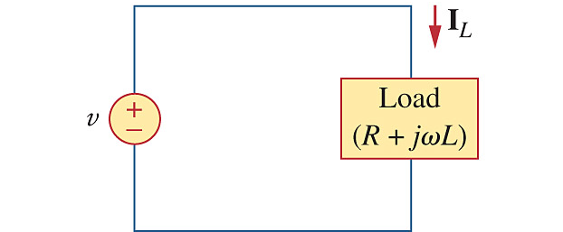

Figure 9.40
For Prob. 9.32.

